Image | Universal Part Number | LandRover Part Number  Base Colour  Use
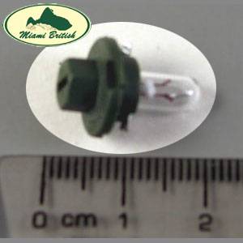 | R509TMBK 12v 1.2w | YAW000020 & YAW100030  Black  Digital Clock
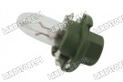 | R509TMGR 12v 2.0w | YAW100040  Green  Instrument Lights
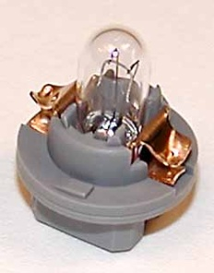 | R509TMGY 12v 0.5w | YAW100020  Grey  Odometer
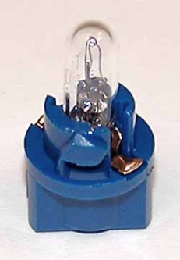 | R509TMBL 12v 1.2W | YAW100050  Blue  High Beam Light
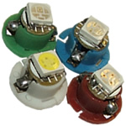 | A new range of LED dashboard bulbs available in White, Blue, Red and Green. These R509TM LED bulbs are a direct replacement for your car's standard R509TM Dashboard/panel bulb
Links:
http://www.autobulbsdirect.co.uk/new_search.php
http://www.lrdirect.com/Part_Numbers_Starting_With_Y/

Bulbs have a cap size-fitting BX8.4D

